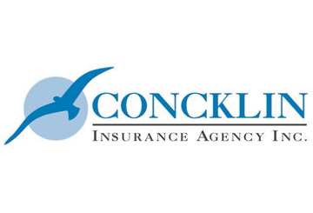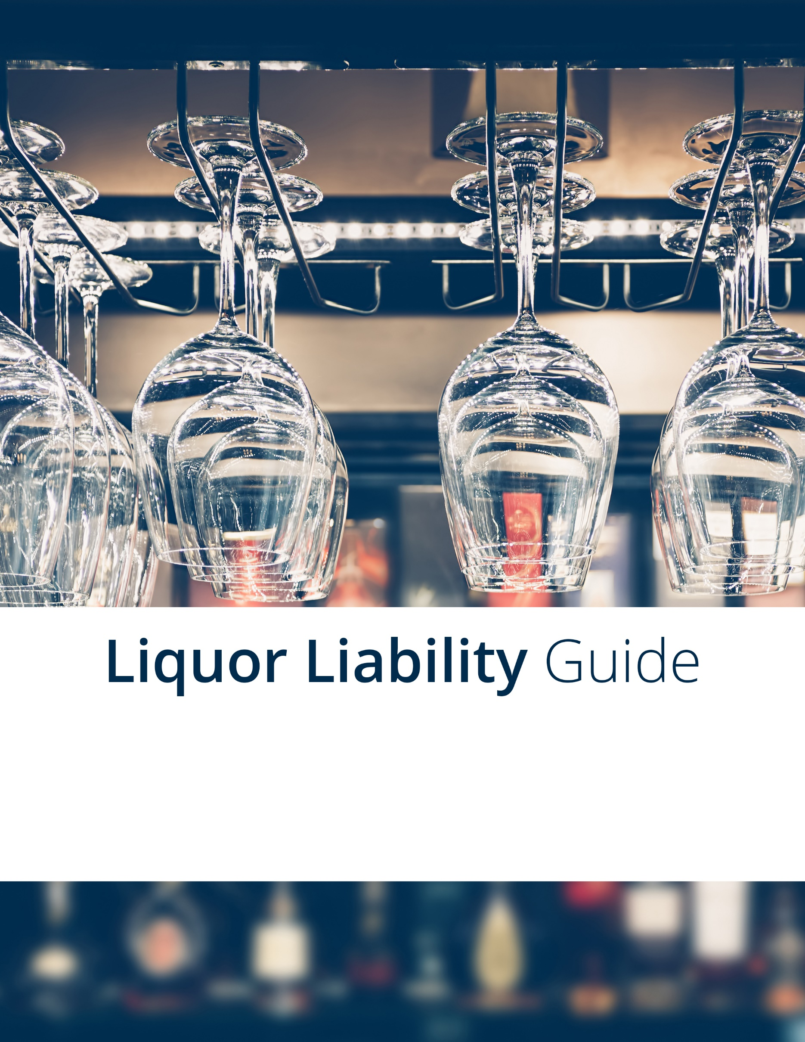

Understanding Liquor Liability 4

What is Liquor Liability? 4

Who is at Risk? 4

The Legal Basis for Liquor Liability 4

Dram Shop Liability Laws 5

Negligence Laws 6

What Can Go Wrong? 6

Mitigating Liquor Liability Through Risk Management 6

Assess Your Risks 6

Take Steps During the Hiring Process 6

Provide Training to Staff 7

Promote Safety and Sobriety at Company-sponsored Events 8

Additional Steps 8

Business can also take the following steps to help control their establishment and reduce liquor liability claims: 8

Document All Incidents 8

Work With Third-party Vendors 8

Create a Written Policy 9

Liquor Liability Insurance 9

What is Liquor Liability Insurance? 9

What Determines Pricing? 10

Find the Right Policy 11

Employee Liquor Liability Agreement Form 13

LIQUOR LIABILITY INCIDENT REPORT 14

Liquor Liability Policy 15

**Purpose** 15

**Scope** 15

**Responsibilities When Serving Alcohol to Patrons** 15

**Responsibilities When Serving Alcohol to Employees at Company Events** 15

**Responsibilities When Consuming Alcohol at Company Events** 16

# Understanding Liquor Liability

Businesses that serve alcohol expect their employees or patrons to have a good time and act in a responsible manner. What they don’t expect, however, is to find out that they are liable for the actions of an intoxicated person. While the vast majority of businesses serve alcohol without incident, the harsh reality is that lawsuits related to liquor liability are filed each day. Making matters worse, all it takes is a single liquor liability claim to put your entire business at risk.

To help your business navigate the risks associated with serving alcohol, this guide will examine the concept of liquor liability and list steps businesses can take to mitigate their risks of facing a costly lawsuit or insurance claim.

When you are done reviewing this guide, remember, Concklin Insurance is here for you and your business. We are ready to help you design an effective risk management plan to limit your business’s liquor liability. What’s more, we can help you find the right insurance policy to protect your business’s bottom line.

## What is Liquor Liability?

The term “liquor liability” refers to an organization’s legal and financial responsibility for the actions of a person who consumes alcohol at its establishment and the consequences of those actions. Under liquor liability laws, businesses can be held liable for bodily injuries and property damage caused by a person who was served alcohol at their establishment.

According to the Insurance Information Institute, liquor liability is not limited to those whose primary business is the sale of alcoholic beverages. Your business may have a liquor liability exposure if you do any of the following:

* Sell or distribute alcohol at your place of business
* Allow patrons or guests to bring their own alcohol and consume it that at your place of business
* Serve alcohol at an event you are hosting
* Allow others to serve alcohol at your venue

## Who is at Risk?

When it comes to liquor liability, a wide range of organizations and individuals can face a lawsuit. Below are some of the most common defendants in alcohol-related lawsuits:

* Owners of restaurants, bars and nightclubs
* Owners of retail stores and convenience stores that sell alcohol
* Businesses and nonprofits that host company parties or social events
* Homeowners who host parties
* College and university organizations that serve alcohol

# The Legal Basis for Liquor Liability

In the United States, dram shop laws and negligence laws form the legal basis for liquor liability. What’s more, each state has specific regulations for the sale and distribution of alcohol. In order to take the appropriate steps to control their risk, it is important for businesses to know the laws in their state and local jurisdiction. For added guidance, refer to the website of the [Alcohol and Tobacco Tax and Trade Bureau](https://www.ttb.gov/), which provides links to each state’s alcoholic beverage authority.

## Dram Shop Liability Laws

Dram shop liability laws exist in 43 states and allow third parties injured by an intoxicated person to sue a business for contributing to that person’s intoxication. For example, if an intoxicated patron leaves your establishment and then causes an auto accident, you could be sued for damages. The same applies for any injuries that occur on your property that are caused by intoxication.

While dram shop laws vary from state to state, typically businesses can be liable if they do any of the following:

* Sell or serve alcohol to minors
* Sell or serve alcohol to a patron who is visibly intoxicated
* Sell or serve alcohol to someone who is habitually drunk

In general, businesses must comply with dram shop laws if they do any of the following:

* Sell alcohol in a commercial capacity (e.g., bars, restaurants and liquor stores)
* Host events where alcohol is consumed (e.g., company parties)
* Furnish or serve alcohol in a commercial capacity (e.g., catering companies)
* Allow patrons to bring their own alcohol and drinks to the establishment (e.g., restaurants and banquet halls)

To learn more about dram shop laws in your state, please visit the National Conference of States Legislatures’ [webpage](http://www.ncsl.org/research/financial-services-and-commerce/dram-shop-liability-state-statutes.aspx) on dram shop civil liability and criminal penalty state statues.

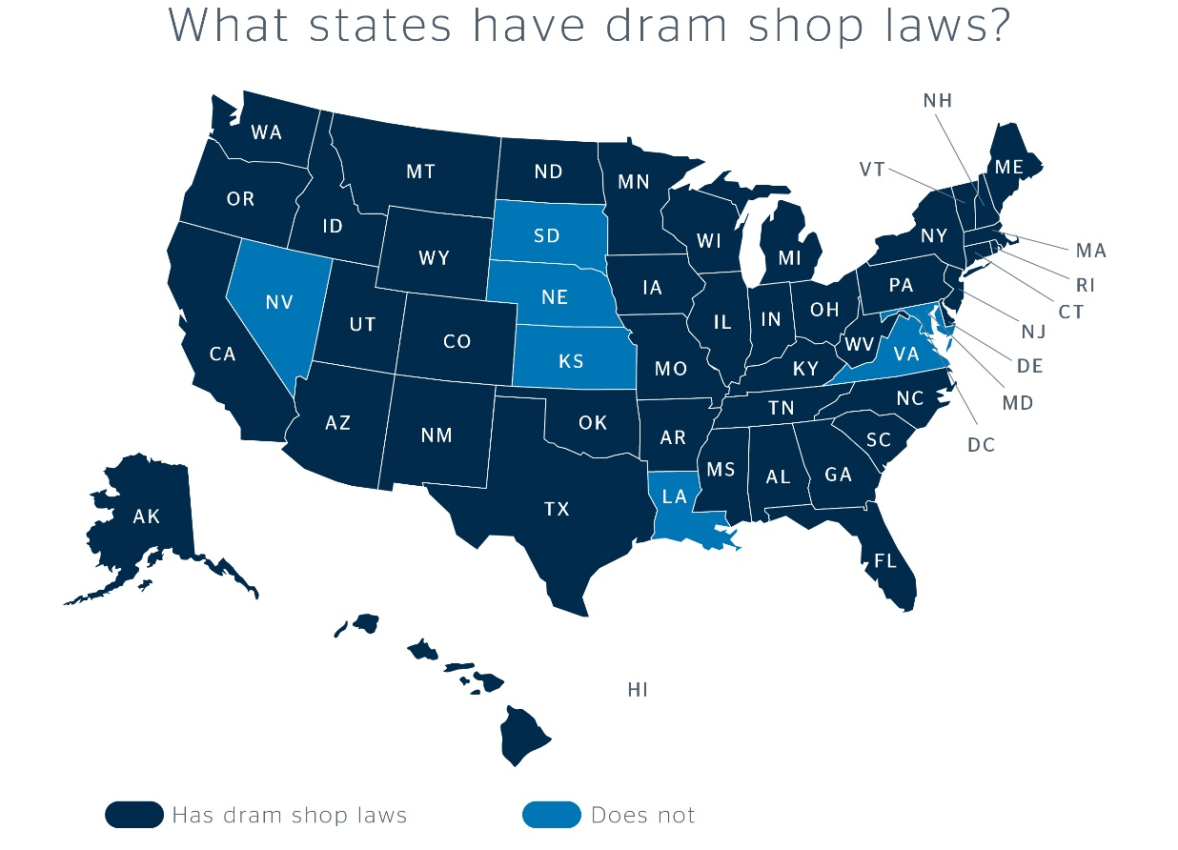

## Negligence Laws

Even in situations where a dram shop law is not applicable, businesses can still be held liable for alcohol-related incidents. All 50 states have negligence laws that can hold businesses responsible for alcohol-related incidents if their actions do not align with what a reasonable person would have done in a similar situation.

# What Can Go Wrong?

When it comes to alcohol-related incidents, there is no shortage of things that can go wrong. Below is an overview of the wide range of injuries and damages for which a business can be held responsible for under liquor liability laws. These incidents can lead to costly judgments against your business, forfeiture of your liquor license or even criminal proceedings:

* **Drunk driving incidents**—Businesses can be held liable for the damages created by drunk drivers who were inappropriately served.
* **Fighting**—Fights and assaults are among the most common causes for liquor liability claims.
* **Sexual assault and harassment**—Businesses can be at fault if someone becomes intoxicated at their establishment or event and sexually assaults or harasses another individual.
* **Trips, slips, falls and other accidents**—If these incidents occur as the result of alcohol consumption, a business may face a premise liability claim.
* **Alcohol poisoning**—The overconsumption of alcohol is all too common. In some cases, overconsumption can lead to alcohol poisoning, a common source of liquor liability claims.

# Mitigating Liquor Liability Through Risk Management

With all of the risks associated with liquor liability, some business owners may question whether it is even worth it to serve alcohol. While some incidents are unavoidable, a proper risk management program can greatly reduce the chances that a business will face a liquor liability claim. In this section, we will explore the aspects of a sound risk management program.

## Assess Your Risks

When implementing a risk management program for liquor liability, it is important to understand the nature of your business. Having a sense of how frequently your business serves alcohol, and in what manner, can help guide your business in the right direction. For example, the risk management processes that a bar or restaurant implements may differ from the actions of a business that only serves alcohol from time to time.

## Take Steps During the Hiring Process

If your business frequently serves alcohol, it is important to be upfront with perspective employees about what will be expected of them. Employers should consider taking the following steps:

* Inform applicants that your establishment takes responsible alcohol service seriously.
* Let applicants know about business policies and state laws related to the service of alcohol.
* Screen applicants for past violations of selling, serving or supplying age-restricted products to minors.
* 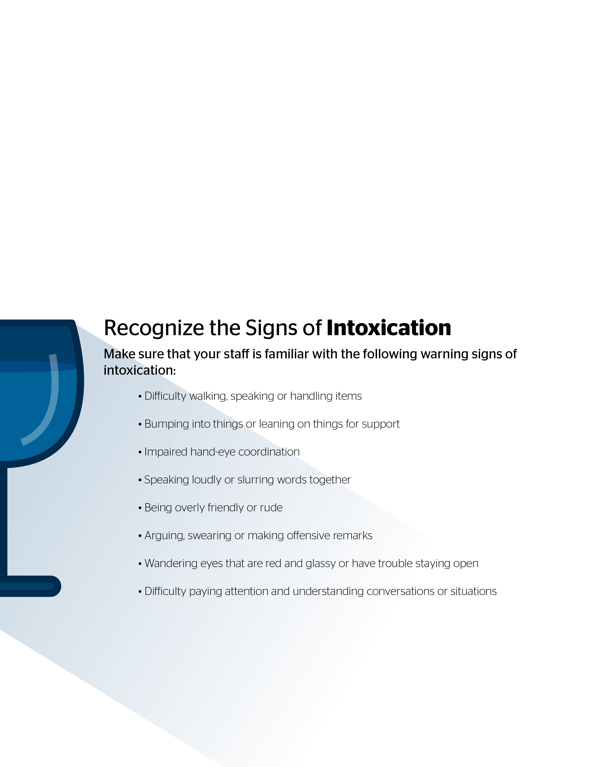Ask applicants to role-play or demonstrate how they would respond to situations such as minors attempting to be served alcohol, someone who does not have an ID to show proof of age or an intoxicated individual who wants to purchase alcohol.

## Provide Training to Staff

It is especially important to provide ongoing training for any employees who serve alcohol. At a minimum, your employee training should address the following:

* State and local liquor laws and requirements
* How to verify age and recognize false identification
* The signs of intoxication or alcohol impairment
* Indicators for when someone may be purchasing alcohol for minors
* How to refuse service and manage difficult situations
* The process for documenting incidents
* A consistent method of measuring and serving alcoholic drinks
* When and who to turn to for assistance
* The consequences of not following policy

Some individuals may become belligerent, hostile or combative when intoxicated. If employees refuse to sell to intoxicated individuals, it is important for management to support their decision and be ready to provide support, including escorting a patron from the premises, arranging for transportation or calling the police, if needed.

## Promote Safety and Sobriety at Company-sponsored Events

To promote the safety and sobriety of your employees and guests at company-sponsored events, review the following recommended control measures:

* Make attendance optional if alcohol will be served at the event.
* Serve drinks to guests rather than offering a self-serve bar.
* Set up bar stations instead of having servers circulate the room. If offered, people are inclined to accept drinks they wouldn’t have otherwise ordered.
* Place signs at each bar reminding employees and guests to drink responsibly.
* Don’t price alcohol too low, as it encourages overconsumption.
* Offer a range of low-alcohol and alcohol-free drinks at no charge.
* Require servers to measure spirits.
* Always serve food with alcohol.
* Close the bar an hour before the scheduled end of the party.
* Do not offer a “last call,” as this promotes rapid consumption.
* Never raffle alcohol or hold contests that involve buying or drinking alcohol.
* Entice guests to take advantage of safe transportation options by subsidizing taxis or promoting a designated driver program.

# Additional Steps

## Business can also take the following steps to help control their establishment and reduce liquor liability claims:

* Design or alter the layout of your establishment in ways that enhance your staff’s ability to monitor patrons’ activities and alcohol consumption.
* Ensure employees can see all sections of your establishment clearly. If possible, install mirrors or surveillance equipment to assist in monitoring corners, hallways or other areas where illegal consumption or other problem behaviors may occur.
* Ensure that temporary displays, decor and service areas will not impede employees’ views of any areas where patrons are consuming alcohol.
* Encourage staff to make themselves visible and to speak to anyone hanging around or acting suspiciously.
* Have policies and procedures in place to ensure inventory is monitored and secured.
* Utilize signage at doorways and other visible areas to make it clear that you uphold liquor laws and will cooperate with law enforcement to address crimes and disruptive behavior.

## Document All Incidents

If an incident occurs, complete a liquor liability incident report documenting the measures taken to control the intoxicated person. This report can aid in your defense if an alcohol-related accident occurs.

## Work With Third-party Vendors

Your risk management program should also include recommendations when working with third-party vendors, such as the following:

* Verify that all vendors you work with, such as a caterer or bartender service, are licensed and insured.
* Stipulate in your vendor’s contract that only those who have received alcohol-awareness training should serve or sell alcohol at your event.
* Require the vendor to provide a certificate of liability insurance that includes liquor liability coverage, naming your company as an additional insured.

If alcohol will be sold or served by outside caterers or bartenders, consider requiring them to carry general liability, products-completed operations and liquor liability insurance with appropriate limits. You should be listed as an additional insured on these polices and require the contractor to provide a certificate of insurance confirming these requirements.

## Create a Written Policy

Once you have identified the risk management steps your business will take, it is important to document those steps in a written policy. This policy will ensure that your employees know what is expected of them at all times and demonstrates to insurance companies that you take liquor liability seriously.

# Liquor Liability Insurance

Unfortunately, even the best risk management programs can never eliminate your liquor liability exposures completely. To make matters worse, people often file lawsuits against businesses that do everything in their power to serve alcohol in a responsible manner. When these lawsuits occur, they can be expensive with costs often exceeding $10,000 for legal fees alone. Thankfully, businesses can turn to liquor liability insurance.

## What is Liquor Liability Insurance?

Liquor liability insurance protects businesses that manufacture, sell or serve alcohol, against claims that occur when a patron drinks too much and injures themselves or someone else. It is meant to protect any establishment that serves alcohol in any form from damages caused by an inebriated patron. Liquor liability insurance covers damages caused by alcohol-related incidents when a commercial general liability policy does not.

Liquor liability insurance also helps businesses afford the high cost of a liquor liability lawsuit. Policies can be used to pay for expenses such as:

* Lawyers’ fees
* Settlements
* Judgments
* Damages and other court fees

Explained another way, if a business is accused of violating a liquor liability law, and that supposed violation causes a loss for someone, a liquor liability insurance policy can cover the cost to make amends.

Liquor liability polices can only protect your business from the costs that develop out of covered alcohol-related incidents listed in your policy. Every policy varies, but most liquor liability policies cover the following:

* Property damage caused by an intoxicated individual
* Personal injuries caused by an intoxicated individual
* Mental damages
* Employee incidents

When alcohol is involved, fights are a common risk. However, many liquor liability policies exclude coverage for assault and battery. Therefore, it’s important to account for this protection when building your policy. It should be noted that assault and battery coverage can also be extended to include specific incidents such as sexual assault, stabbings and shootings.

It should also be noted that liquor liability insurance won’t cover claims that arise from the sale of alcohol to minors or similar illegal transactions. Be sure your employees are instructed to verify patrons are of a legal drinking age.

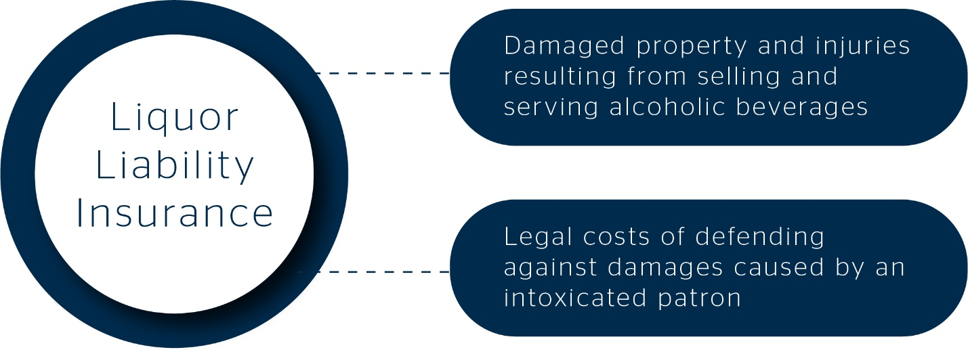

## What Determines Pricing?

The underwriting process for liquor liability insurance can differ depending on the type of business you conduct. In general, the following four factors determine the rating and pricing of coverage:

1. **Type of venue**—When examining a business’s risk, underwriters look to identify the primary purpose of a venue. If you own a restaurant, the primary purpose of your venue is to serve food, so you are generally considered to have less risk than a nightclub or tavern.
2. **Location of the venue**—Liquor laws can vary drastically depending on the jurisdiction. Each state has its own scoring system based on the nature of local dram shop laws. Dram shop laws impose certain liability standards on area venues that serve alcohol. Because the strictness of these laws may change from location to location, where you operate your business can have a major impact on how your liquor liability insurance is priced.
3. **Percentage of liquor sales**—As a general rule, the more alcohol sales you make, the higher your premiums will be. This factor tends to have more of an impact on pricing than venue type, as a restaurant that has a high percentage of alcohol sales may be priced similar to a bar.
4. **Individual traits of the risk**—There are a number of miscellaneous variables underwriters take into consideration when pricing out policies, including the following:
   * Types of entertainment offered
   * Experience level of management
   * Formal loss-control measures
   * Security measures and procedures for dealing with intoxicated patrons

## Find the Right Policy

Consult Concklin Insurance today to learn more about how liquor liability can be used to protect your business. We have the expertise to help you mitigate your risks and protect your bottom line.

# Employee Liquor Liability Agreement Form

As a condition of employment at <Insert Company Name>, I agree to the following company rules regarding the sale and distribution of alcoholic beverages:

1. I have completed <Insert Company Name>’s formal Liquor Liability Training Program. Any questions I had regarding the program have been fully explained to my satisfaction.
2. I will not sell beer, ale, wine or liquor to any person that is not of legal drinking age at the time of the sale.
3. I will not sell any beer, ale, wine or liquor to any person who appears intoxicated or is acting disorderly.
4. I understand the state, county and city laws regarding the legal hours of the day during which I may sell beer, ale, wine or liquor to a customer. I will not sell or serve beer, ale, wine or liquor to anyone during the restricted hours.
5. I will not purchase any beer, ale, wine or liquor from my employer for the use or benefit of any underage person or any intoxicated person.
6. I understand <Insert Company Name> will only accept certain forms of personal identification as outlined in my training program, and I will accept no other form of identification from anyone purchasing beer, ale, wine or liquor.
7. If any customer does not clearly appear to be at least 30 years old, I will request acceptable identification and verify that the customer is of legal age before making the sale.
8. I understand that if I do make an illegal sale of beer, ale, wine or liquor, I may be personally arrested and charged with a criminal offense. If I am found guilty, I could be fined, jailed or both. I understand I am personally responsible for my attorney fees as well as paying any fines.
9. I understand that any infraction of my employer’s rules concerning the sale of beer, ale, wine or liquor could result in automatic termination.
10. I understand that my activities will be monitored by <Insert Company Name> as well as by state and local law enforcement investigators.

I have read, understand and agree to comply with the liquor liability policy rules as stated above.

______   
Employee Signature  
  
____

Date

# LIQUOR LIABILITY INCIDENT REPORT

In the event of an incident:

1. Record all relevant information surrounding the potential claim in the form provided below. This includes denying entry to anyone who is intoxicated, refusing service, ejecting patrons, rejecting use of false ID, and recording an accident or altercation. Include the name of alleged intoxicated person and contact information of any witnesses, staff or volunteers that were present or have information relevant to the incident.
2. Once a claim or potential claim is identified, immediately contact Concklin Insurance at 630.268.1600.
3. Refer any discussions with the claimant (injured party) to Concklin Insurance. Do not discuss or admit liability with potential claimants.

Establishment name:

Date:

Name of alleged intoxicated person(s) or person(s) injured:

Arrival time: Departure time:

Brief description of incident/complaint:

Intervention strategies used:

Bartenders/servers on staff:

Witness name(s):

Address(es):

Telephone number(s): Home Mobile

Authorities contacted? Yes ❒ No ❒

If yes, whom:

Additional comments: Please note any relevant facts that you are aware of regarding the alleged intoxicated person, injury, or property damage or loss.

Prepared by: Position:

Date:

Provided by: Concklin Insurance 240 South Westmore Lombard, IL 60148

630.268.1600 ◆ https://insurance.concklin.com/

# Liquor Liability Policy

Location:

Effective Date: <Insert Effective Date

Revision Number: 1

<Insert Company Name>

**Purpose**

For the safety of all employees and patrons, <Insert Company Name> requires all employees to adhere to responsible practices when serving and drinking alcoholic beverages. After reading this policy, employees will understand the following:

To whom alcohol can be served

When alcohol can be served

The amount of alcohol that can be served

Responsible practices for serving and drinking alcohol during company events

**Scope**

This policy applies to all employees who serve alcohol, as well as to employees who consume alcohol at company-sponsored events, both on-site and away from <Insert Company Name> property.

**Responsibilities When Serving Alcohol to Patrons**

<Insert Company Name> is responsible for ensuring that employees and patrons abide by all state and local laws regarding the service of alcohol. In an effort to promote compliance and safety, <Insert Company Name> expects all employees to follow company policy. Failure to do so may result in disciplinary action, up to and including termination. <Insert Company Name> expects employees to adhere to the following rules when serving alcohol to patrons:

Refuse service of alcohol to any person under 21 years of age or to any person who appears visibly intoxicated.

Require any patron who appears to be underage to present government-issued photo identification with his or her date of birth indicating that he or she is at least 21 years of age. If the identification appears to be forged or tampered with, the employee checking the identification should inform his or her manager.

Immediately notify a manager or supervisor when a patron shows visible signs of intoxication. The manager or supervisor should then inform the patron that it is not legal to continue service of alcoholic beverages to the individual who shows signs of intoxication.

Urge any patron showing visible signs of intoxication to avoid driving home. If the intoxicated patron drives away, the employee should note the patron’s license plate number and contact local law enforcement.

After refusing service to any patron, an employee should note the patron’s appearance and clothing on an incident report, which should be given to and recorded by his or her manager.

Dispense all alcohol in measured quantities.

Use good judgment concerning the number of drinks served at a time.

Participate in a designated alcohol-awareness training program within [insert time period] of beginning employment.

**Responsibilities When Serving Alcohol to Employees at Company Events**

<Insert Company Name> may enlist the help of employees when serving alcohol at company-sponsored events. Employees who agree to serve alcohol at company events are expected to follow all aforementioned rules as well as the following:

Obtain executive approval before hosting a company event. A member of the executive team should be present during the entire event.

Limit the number of alcoholic drinks served to two per guest. Serve alcohol over a time period of no more than two hours.

Offer food during the time period that alcohol will be served to limit intoxication.

Provide transportation options to employees who cannot safely drive home.

**Responsibilities When Consuming Alcohol at Company Events**

<Insert Company Name> may sponsor company events during which alcohol is served. In an effort to promote responsible alcohol consumption at all company-sponsored events, <Insert Company Name> requires employees to follow the guidelines listed below:

Behave in a professional manner and follow all company policies.

Avoid alcohol if you are under 21 years of age.

Arrange for a safe ride home if you have had too much to drink.

Ensure that guests abide by all company policies. If your guest shows signs of intoxication, do not allow him or her any more alcohol.